PYTHON

IN CLASS PROGRAMMING-4

Student ID: 16269844

Name: Naga Srividya Varanasi

1.Implement Naïve Bayes method using scikit-learn. Use iris dataset available in

https://umkc.box.com/s/pm3cebmhxpnczi6h87k2lwwiwdvtxyk8

Use cross validation to create training and testing part

Evaluate the model on testing part

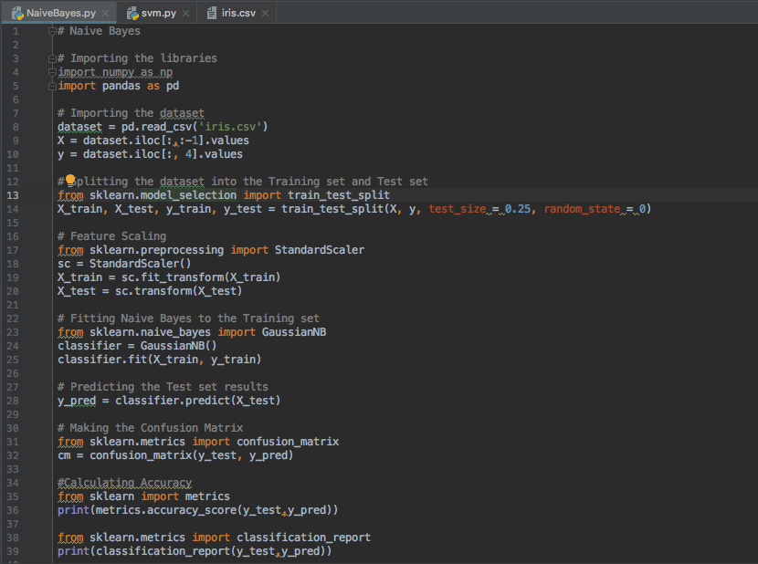

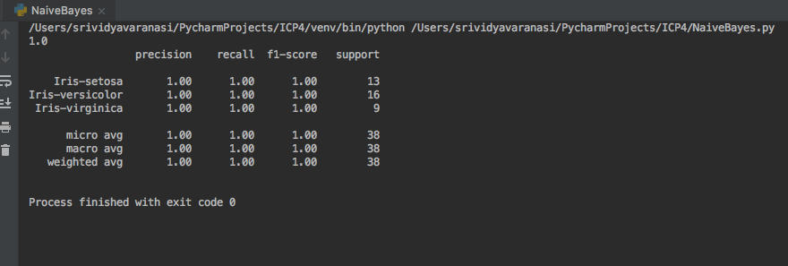

2.Implement linear SVM method using scikit library. Use the same dataset above.

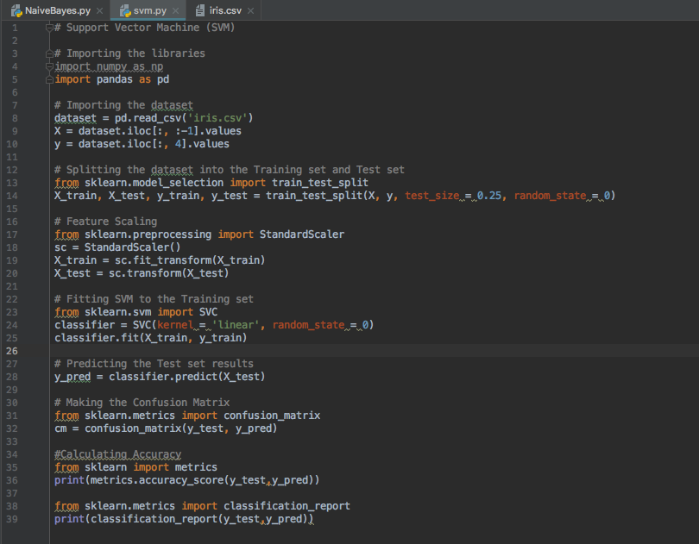

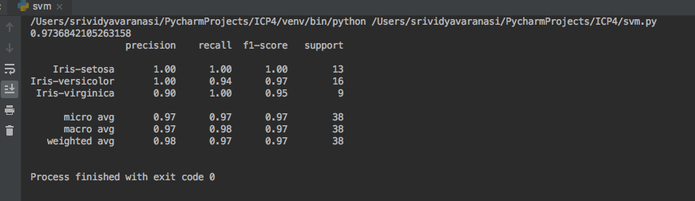

3. Compare the results and report accuracy, precision, F - measure and Recall.

Answer:

For Naïve Bayes algorithm: The model is very accurate for classifying setosa and versicolor almost 100%.

For support vector machine: The model is accurate for classifying setosa and versicolor and is almost 97%. Also, the precision, recall, F-1 score is compared. For setosa, the precision, recall and f-1 score are same (i.e 100%). For versicolor, the precision is 100% where as the recall is 94% and the f-1 score is 97%. For virginica, the precision is 90%, the recall is 100% and f-1 score is 100%.